**Final Project INFO 6105 Report**

**Prediction of the FIFA Player’s Wage**

**Group_7 Member**

Xiaoge Zhang, Peichun Tseng, Mibin Zhu, Yezhi Miao, Mingyu Liu, Rohan Choudhary

**Key Words**

Step-wise Regression, Logistic Regression, Linear Regression, AIC, BIC, R-square

**Introduction**

In this assignment, we investigated the FIFA soccer players dataset and trying to build the model that can predict the players' wage. The data is scraped from the website [https://sofifa.com](https://sofifa.com/) by extracting the Player personal data and Player Ids and then the playing and style statistics in FIFA 2018.

**Background**

With the growing numbers of soccor players in each club, how to evaluate a player’s wage and give them a proper position targeting have become a big problem for each soccor club. Developing an appropriate positioning method and salary level will effectively improve this situation.

**Goals**

The purpose of this project is to establish an evaluation plan for the player’s wage depending on their personal information, the position they are playing in the match, the goals and mistakes they perfrom in the match and so on.

**Methodology**

**1. Linear Regression**

In [statistics](https://en.wikipedia.org/wiki/Statistics), linear regression is a [linear](https://en.wikipedia.org/wiki/Linearity) approach to modelling the relationship between a scalar response and one or more [explanatory variables](https://en.wikipedia.org/wiki/Explanatory_variable). The case of one explanatory variable is called [simple linear regression](https://en.wikipedia.org/wiki/Simple_linear_regression). For more than one explanatory variable, the process is called multiple linear regression. This term is distinct from [multivariate linear regression](https://en.wikipedia.org/wiki/Multivariate_linear_regression), where multiple correlated dependent variables are predicted, rather than a single scalar variable.

**2.** **Logistic model**

In [statistics](https://en.wikipedia.org/wiki/Statistics), the logistic model is a widely used [statistical model](https://en.wikipedia.org/wiki/Statistical_model). In its basic form it uses a [logistic function](https://en.wikipedia.org/wiki/Logistic_function) to model a [binary](https://en.wikipedia.org/wiki/Binary_variable) [dependent variable](https://en.wikipedia.org/wiki/Dependent_variable), although many more complex [extensions](https://en.wikipedia.org/wiki/Logistic_regression#Extensions) exist. In [regression analysis](https://en.wikipedia.org/wiki/Regression_analysis), logistic regression is [estimating](https://en.wikipedia.org/wiki/Estimation_theory) the parameters of a logistic model. Mathematically, a binary logistic model has a dependent variable with two possible values, such as pass/fail, win/lose, alive/dead or healthy/sick; these are represented by an [indicator variable](https://en.wikipedia.org/wiki/Indicator_variable), where the two values are labeled "0" and "1".

**3. Step-wise Regression**

In [statistics](https://en.wikipedia.org/wiki/Statistics), stepwise regression is a method of fitting [regression models](https://en.wikipedia.org/wiki/Regression_model) in which the choice of predictive variables is carried out by an automatic procedure. In each step, a variable is considered for addition to or subtraction from the set of [explanatory variables](https://en.wikipedia.org/wiki/Explanatory_variable) based on some prespecified criterion. Usually, this takes the form of a sequence of [F-tests](https://en.wikipedia.org/wiki/F-test) or [t-tests](https://en.wikipedia.org/wiki/T-test), but other techniques are possible, such as [adjusted R2](https://en.wikipedia.org/wiki/Adjusted_R-squared) and [Akaike information criterion](https://en.wikipedia.org/wiki/Akaike_information_criterion).

**4. Interaction effects & Regularization**

In [statistics](https://en.wikipedia.org/wiki/Statistics), an interaction may arise when considering the relationship among three or more variables, and describes a situation in which the effect of one causal variable on an outcome depends on the state of a second causal variable. Although commonly thought of in terms of causal relationships, the concept of an interaction can also describe non-causal associations. Interactions are often considered in the context of [regression analyses](https://en.wikipedia.org/wiki/Regression_analysis) or [factorial experiments](https://en.wikipedia.org/wiki/Factorial_experiments).

**Specifications**

[Web Scraping](http://en.wikipedia.org/wiki/Web_scraping) is a technique employed to extract large amounts of data from websites whereby the data is extracted and saved to a local file in your computer or to a database in table format.

The Data is collected from <https://sofifa.com> through the process of web scraping. We were able to collect data and in the csv file able to read from that. Web scraping is an essential technique that allows us to read the content from web. Whenever the data is updated the csv should be updated. We collected the data and analyzed the essential features that have a huge impact on the determination of wages. The features that are present like following.

Non-Essential attributes : Name, Age, Nationality, Photo, Flag;

Essential Attributes : Composure, Marking, Standing Tackle, Reflexes;

Non essential features are those attributes that do not have impact upon the wages of the players and are independent , not causing any effect on the target variable. Essential ones are that have impact on the target variable and are closely related. For the models' feature, we first check whether it contains the NaN values and take a glance that whether the range of its values make sense.

Same as wage, value column also has special symbols that is $ and Euros so it is essential we split the data correctly and effectively model it. It is very essential that splitting is done correctly because the whole value depends on that.

Then, there are several positions have been scored for each player. The score is from 0 to 100. We convert the string into float number and replace the NaN value with the median of each column.

Data cleansing or data cleaning is the process of detecting and correcting corrupt or inaccurate [records](https://en.wikipedia.org/wiki/Storage_record) from a record set, [table](https://en.wikipedia.org/wiki/Table_(database)), or [database](https://en.wikipedia.org/wiki/Database) and refers to identifying incomplete, incorrect, inaccurate or irrelevant parts of the data and then replacing, modifying, or deleting the [dirty](https://en.wikipedia.org/wiki/Dirty_data) or coarse data.

Data cleansing may be performed [interactively](https://en.wikipedia.org/wiki/Interactively) with [data wrangling](https://en.wikipedia.org/wiki/Data_wrangling) tools, or as [batch processing](https://en.wikipedia.org/wiki/Batch_processing) through [scripting](https://en.wikipedia.org/wiki/Script_(computing)).

After cleansing, a [data set](https://en.wikipedia.org/wiki/Data_set) should be consistent with other similar data sets in the system. The inconsistencies detected or removed may have been originally caused by user entry errors, by corruption in transmission or storage, or by different [data dictionary](https://en.wikipedia.org/wiki/Data_dictionary) definitions of similar entities in different stores. Data cleaning differs from [data validation](https://en.wikipedia.org/wiki/Data_validation) in that validation almost invariably means data is rejected from the system at entry and is performed at the time of entry, rather than on batches of data.

Wages if depending on some essential feature has continuous set of zeros or erroneous values then the output we will be achieving will be completely wrong. Hence one method of achieving data cleaning is that we replace null values , replacing zero values with medians and also checking the integrity of the data in columns. It is very essential that right data is present because wrong data can create wrong analysis.

Correlation coefficients can vary numerically between 0.0 and 1.0. The closer the correlation is to 1.0, the stronger the relationship between the two variables. A correlation of 0.0 indicates the absence of a relationship. If the correlation coefficient is –0.80, which indicates the presence of a strong relationship. A statistically significant correlation is indicated by a probability value of less than 0.05. This means that the probability of obtaining such a correlation coefficient by chance is less than five times out of 100, so the result indicates the presence of a relationship.

A positive correlation coefficient means that as variable 1 increases, variable 2 increases, and conversely, as variable 1 decreases, variable 2 decreases.

We have value, overall, reactions, potential, RCM, LCM, CM (positions) and such features have the highest correlation that helps us identify high correlation. The top 10 sorted values are :

"We choose several features for constructing different models and investigate which model is the best one. We first choose ten highest correlation with wage, which are 'Preferred Foot', 'Value', 'Overall', 'Reactions', 'Potential', 'RCM', 'LCM', 'CM', 'Composure', 'RS'."

Values for the different features : ['Left', 'Value', 'Overall', 'Reactions', 'Potential', 'RCM', 'LCM', 'CM', 'Composure', 'RS']

“Value” 0.858216",

"International Reputation 0.6688",

"Overall 0.572363",

"Reactions 0.496137",

"Potential 0.486711",

"RCM 0.436270",

"LCM 0.436270",

"CM 0.436270",

"Composure 0.419800",

"RS 0.396013",



Picture 1

These values are having the highest correlation but cannot be selected based directly on this as features can be interrelated. This has to be checked as it can have a huge impact and it completely changes the interpretation.

It turns out that the p value between chosen features are very small, which means the features are significant to each others.

Null hypothesis is a general statement that there is no relationship between two measured phenomena.

P-value gives us the probability of finding an observation under an assumption that a particular hypothesis is true. This probability is used to accept or reject that hypothesis. Removal of different features from the dataset will have different effects on the p-value for the dataset. We can remove different features and measure the p-value in each case. These measured p-values can be used to decide whether to keep a feature or not.

Next, we compare the correlation between features and remove one of two features that have a correlation higher than 0.9

Next we will be selecting the columns based on how they affect the p-value. Now we will create the model that show features having highest effect on the target variable wages.

**Results**

**1. Linear Regression**

We use the ols function as the module to train my data, which is the least squares method as a mathematical optimization technique. It finds the best function match for the data by minimizing the sum of the squares of the errors. The least squares method can be used to easily obtain unknown data and minimize the sum of the squares of the errors between the obtained data and the actual data. The least squares method can also be used for curve fitting. Other optimization problems can also be expressed by least squares by minimizing energy or maximizing entropy.

We use the modelIndex linear regression library to train our model and calculate the accuracy with testing data. Then, we choose the model which has max R square below.

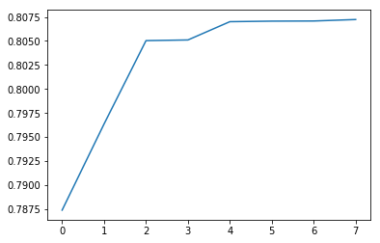

Picture 2

We show the results of the test data comparing target variable with the predict result. The distribution seems corresponding to each other.

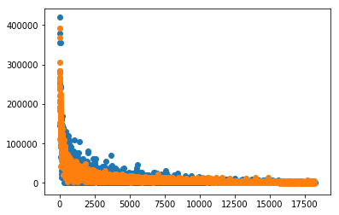

Picture 3

The scores_CV shows the average cross validation scores of every model. We can clearly see that the score increasing drastically after we using more than two features in a model. As the result, we can select the model which can explain the observed data better.

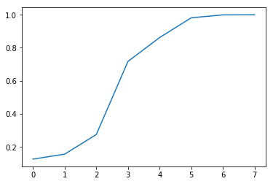

Picture 4

We also use the AIC, BIC and adjusted R^2. AIC means Akaike Information Criterion, is a standard for measuring the goodness of statistical model fitting. BIC means Bayesian Information Criterion, is an important part of subjective Bayesian induction theory.

Adjusted R-Square, is actually multiplying the "divided by one heap" in the R-Square equation by "a number slightly larger than one" and then subtracted by one. The number of samples affects "a number slightly larger than one", thus offsetting the effect of the number of samples on R-Square, contain really 0~1, the bigger the better.

For the output conclusion, the module with the biggest scores is the module 6 which is the RCM with R-Square as 0.807, after the cross validation, we also get AIC and BIC as about 2.72e+05.



Picture 5

**2.** **Logistic model**

We try to build the logistic model that can predict a player’s wage. The value of wage in the dataset are separated to binary categorical variable.

**Logistic VS. Linear Regression**

Logistic regression gives you a discrete outcome but linear regression gives a continuous outcome. A good example of a continuous outcome would be a model that predicts the value of a house. That value will always be different based on parameters like it’s size or location. A discrete outcome will always be one thing (you have cancer) or another (you have no cancer).

**Advantages**

˙efficient--- not require too many computational resources

˙logistic regression does work better when you remove attributes that are unrelated to the output variable.

˙Used to measure the performance of other more complex Algorithms.

**When to use it**

Using logistic regression when your Y variable takes on only two values (e.g when you are facing a classification problem).

Step1.

Selected “wage” to be a binary categorical variable and calculated the correlation with other features. We define 1 of top 40% high wage, and other are 0. We will choose top 20 features that are highest correlation value with wage.

Step2.

Then, we investigate the significant, p-value, between top 20 correlation features as the diagram. When the values higher than 0.05, which relate not significant. At result, we choose seven features that is significant to build the models.

Step3.

We add features one by one, and built logic models separately. And use fit() method to build the model that we can calculate the score. The method of calculating score is named accuracy mean. We choose 30% of players to test this model. After we split the training and testing dataset, the most accuracy of the model is about 0.8577. We can obtain the model 7 (8 features) is the most accuracy to testing data.

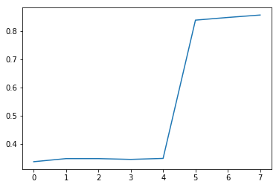

Picture 6

Then, we can exam further by cross validation. After we exam the dataset by cross validation, the mean accuracy are lightly less than one we calculated previously, but overall, the model seven still stand out.

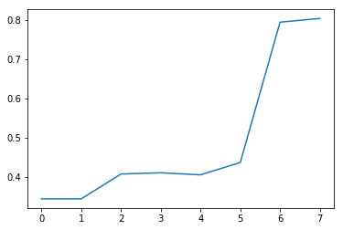

Picture 7

**3. Step-wise Regression**

We developed 11 steps to realize the whole step-wise Regression as following.

1. Compare the correlation between two variables;

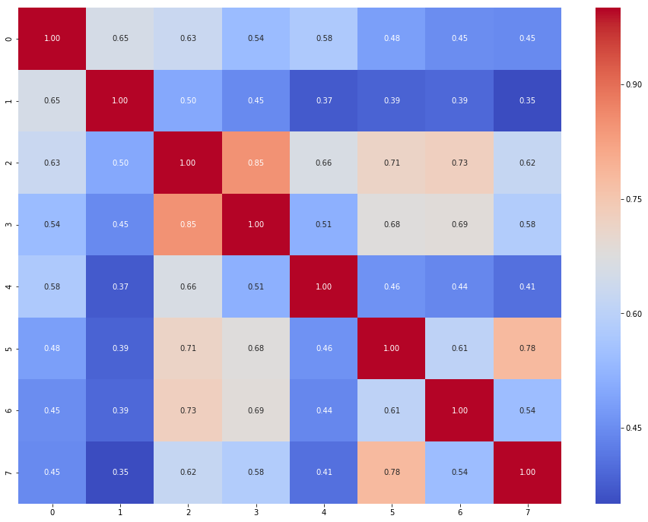

Picture 8

2. Calculate VIF Factor of 8 features, and exclude “value” features since their value less than 5, which means that they are not multicollinearity; 

Picture 9

3. First, there is only one independent variable that explains the largest variation of the dependent variable. Then try to add another independent variable to see if the variation of the dependent variable can be explained by the whole model after adding. this process iterates over and over until there are no independent variables to meet the conditions for joining the model. Using forward step, X one by one, each time entering the minimum X of the P-value, until the X that is not entered does not significant. This process return some features that satisfy the requirement;

4. Compare the correction of two features which return in previous step;

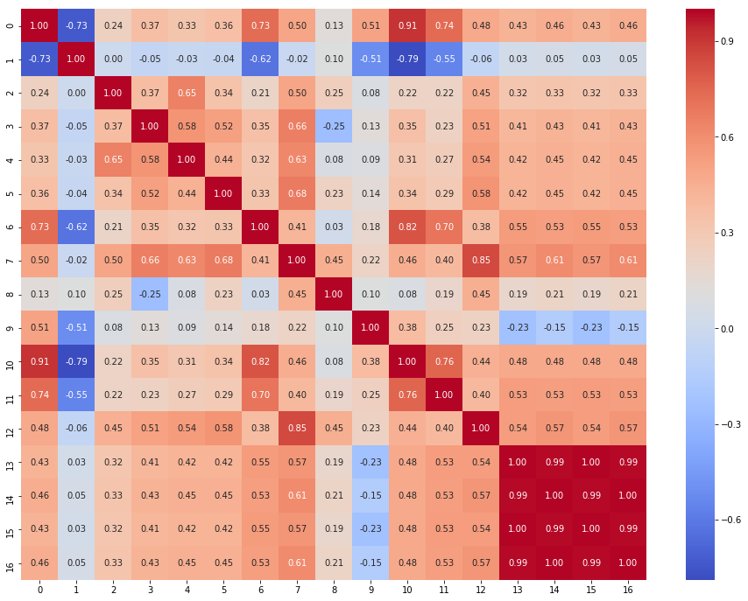

Picture 10

5. Check VIF factor of these features;

6. Use ols to fit the model;

7. Split the dataset into test part and train part;

8. Use forward step, X one by one, each time entering the maximum X of the R squared, until the X that is not entered does not significant;

9. Compare the correction of two features which return in previous step;

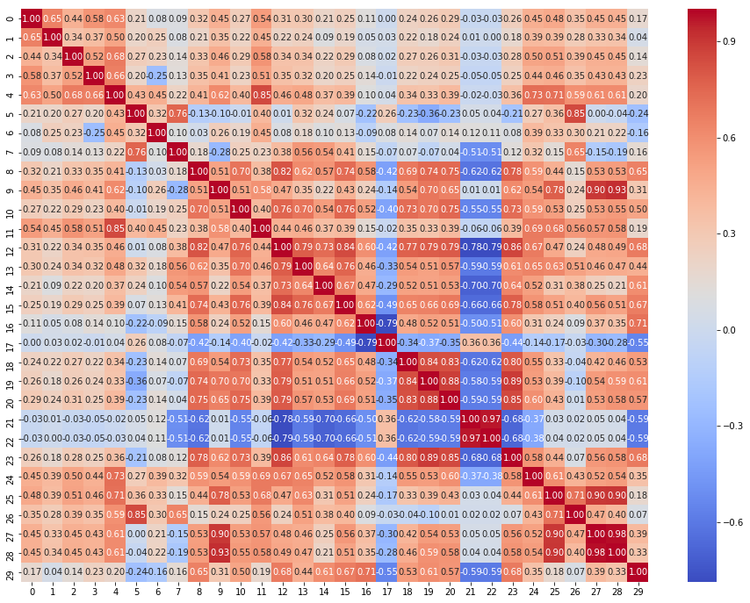

Picture 11

10. Check VIF factor of these features;

11.Use cross validation to test the score of this model.

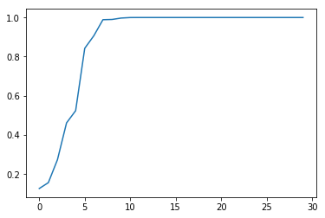

Picture 12

The basic idea of ​​stepwise regression is to introduce variables into the model one by one. After each introduction of an explanatory variable, an F-test is performed, and the explanatory variables that have been selected are subjected to t-test one by one. When the originally introduced explanatory variables are changed due to the introduction of later explanatory variables If it is no longer significant, delete it. To ensure that only the significant variables are included in the regression equation before each new variable is introduced. This is an iterative process until neither a significant explanatory variable is selected into the regression equation nor an insignificant explanatory variable is removed from the regression equation. In order to ensure that the final set of explanatory variables is optimal.

Based on the above ideas, stepwise regression can be used to screen and eliminate the variables that cause multicollinearity. The specific steps are as follows: first, use the explanatory variables to make a simple regression for each of the explanatory variables considered, and then explain the largest contribution to the explained variables. Based on the regression equation corresponding to the variable, the remaining explanatory variables are gradually introduced. After a stepwise regression, the explanatory variables that are finally retained in the model are both important and have no serious multicollinearity.

For advantage, its main idea is to introduce the regression equations one by one in all the independent variables considered, the magnitude of the effect, or the size of the contributions. The variables that are not significant will never be used. Introduce the regression equation. In addition, variables that have been introduced to the regression equation may lose importance after introducing new variables, but need to be removed from the regression equation. Introducing a variable or removing a variable from a regression equation is called a step of stepwise regression. Each step is tested to ensure that the regression equation contains only variables that have significant effects before introducing new variables, but not significant. The variable has been removed.

For the definition of the Multi-colinearity, for regression algorithms, whether it is general regression, logistic regression, or survival analysis, multiple predictors must be considered at the same time. Therefore, multicollinearity is inevitable. In many cases, multicollinearity is a common phenomenon. . How to deal with multicollinearity in constructing predictive models is a more subtle issue. It can neither be uncontrolled nor across the board, and it should be eliminated that all collinearity should be eliminated. We choose step-wise regression to address this problem.

For conclusion part, after testing the model, the accuracy is almost 1. As a result, we can consider that players’ wage is relevant to various features, up to 30 features. Such as age, weight, strength, crossing, ballcontrol, height, balance, acceleration and so on.

**4. Interaction effects & Regularization**

Here is the improvement of this model, we use the stepwise regression model select by p-value to exam the interaction effects. We first investigate the original model and then choose first two features product to last two features for a new model.

At the beginning of this part, you will see the stepwiseResult_pavlue we got from stepwise regression model, we will also use the result from that model too, you could see the params of the result here.

Firstly, we need to divide df into two part, train and test. Then, we use Least square method to train the data from train part, we will get the R-squared of the result is 0.812, is quiet great.



Picture 13

Next step, we will use Interaction effects function, in this function, we will multiply the two features, and use the method to determine whether there is correlation between the two features. If there is, the original feature can be replaced with this, we need to use rename function to delete the space of words in params, we got the result of test data and use the above original model for examing the regularization by using fit_regularized method. The parameter, L1_w1, is 1, which means it is ridge fit for the model. After regularization, we get R^2 is about 0.8014, this function prevents transition fitting, so, this is a great function.



Picture 14

As the conclusion part, we found there has strong interaction effects at value feature with International Reputation feature and Skill Moves feature with Reactions feature. Also, it is better to use Regularization function by using Ridge model than using Interaction effects.

The following is the explaination of previous module’s parameters:

Parameter name : alpha

Type : {float, array-like}, shape (n_targets)

Note :Regularization dynamics, must be a positive floating point number. Regularization improves the condition of the problem and reduces the estimator variance. Larger values specify stronger regularization. In other models, such as LogisticRegression or LinearSVC, α. If an array is passed, a specific penalty is assumed on the target, so they must always be numeric, that is, the number equals the number of characteristics.

Parameter name : coef_

Type : Array, shape (n_features,) or (n_targets, n_features)

Description : weight vector

Parameter name : intercept_

Type : float | array, shape = (n_targets,)

Note : the independent item in the decision function, the intercept, is set to 0 if fit_intercept=False

Parameter name : n_iter_

Type : array or None, shape (n_targets,)

Description : the actual number of iterations for each goal. Can only be used with sag and LSQR solvers. The other solvers return None.

**Conclusion**

We carefully select the proper features of the model by investigating the correlation and the significant. By using the linear regression model, we build the model with the choosing features and calculate the R^2 value of the model so that we obtain the best model by selecting the highest R^2. Also, we plot the test target values and the predicted result of test data. The distribution is quit similiar. In order to get more reliable model, we exam the cross validation and calculate the R^2, AIC, BIC after cross validation. Besides, we also use Logistic model to calculate the accuracy value and exam the cross validation for the same features. To conclude, these two models are all effective.

In step-wise regression part, we firstly check whether it exist the multi-colinearity relationship in out variables by Variance Inflation Factor (VIF). It turns out most of the variables are multi-colinearity, but we still can choose the better model from it. So, we use forward stepwise regression trying to get the better model. We implement two kinds of stepwise regression. First, we select the less p-value predictor variable and add into our model. Second one, we calculate the R^2 and select the variable which can let the model has lowest R^2.

In interaction effects part, we consider the interaction effects in our model, but unfortunately the model we get is worse than the original one, which is the features selected by first stepwise regression.

In regularization part, we use regularization to undermine the overfitting problem by Ridge regression. We investigate different lambda and get the model with the highest R^2. As the result, it seems a little bit improve the original model (first stepwise regression).

**References & Sources**

[1]. Linear Regression : https://www.statsmodels.org/stable/regression.html;

[2]. [AIC and Adjusted](https://stats.stackexchange.com/questions/140965/when-aic-and-adjusted-r2-lead-to-different-conclusions) R^2 : https://stats.stackexchange.com/questions/140965/when-aic-and-adjusted-r2-lead-to-different-conclusions;

[3]. Generalized Linear Models : https://scikit-learn.org/stable/modules/linear_model.html;

[4]. [sklearn.model_selection](https://scikit-learn.org/stable/modules/classes.html#module-sklearn.model_selection) : https://scikit-learn.org/stable/modules/generated/

sklearn.model_selection.cross_val_score.html#examples-using-sklearn-model-selection-cross-val-score;

[5]. [Stepwise regression](https://datascience.stackexchange.com/questions/24405/how-to-do-stepwise-regression-using-sklearn) : https://datascience.stackexchange.com/questions/24405/how-to-do-

stepwise-regression-using-sklearn;

[6]. [sklearn.linear_model](https://scikit-learn.org/stable/modules/classes.html#module-sklearn.linear_model).Ridge : https://scikit-learn.org/stable/modules/generated/

sklearn.linear_model.Ridge.html;